**Array of Objects**

When a class is defined, only the specification for the object is defined; no memory or storage is allocated. To use the data and access functions defined in the class, you need to create objects.

**Syntax:**

ClassName ObjectName[number of objects];

The Array of Objects stores *objects*. An array of a class type is also known as an array of objects.

**Example#1:**   
Storing more than one Employee data. Let’s assume there is an array of objects for storing employee data emp[50].

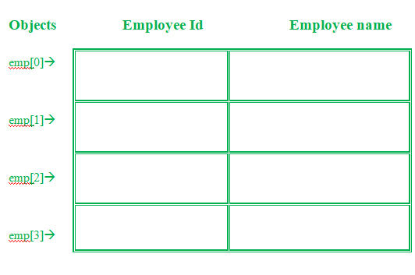

Below is the C++ program for storing data of one Employee:

**C++**

// C++ program to implement

// the above approach

#include<iostream>

**using** **namespace** std;

**class** Employee

{

**int** id;

**char** name[30];

**public**:

**void** getdata();//Declaration of function

**void** putdata();//Declaration of function

};

**void** Employee::getdata(){//Defining of function

  cout<<"Enter Id : ";

  cin>>id;

  cout<<"Enter Name : ";

  cin>>name;

}

**void** Employee::putdata(){//Defining of function

  cout<<id<<" ";

  cout<<name<<" ";

  cout<<endl;

}

**int** main(){

  Employee emp; //One member

  emp.getdata();//Accessing the function

  emp.putdata();//Accessing the function

**return** 0;

}

Let’s understand the above example –

* In the above example, a class named Employee with id and name is being considered.
* The two functions are declared-
  + **getdata():** Taking user input for id and name.
  + **putdata():** Showing the data on the console screen.

This program can take the data of only one Employee. What if there is a requirement to add data of more than one Employee. Here comes the answer Array of Objects. An array of objects can be used if there is a need to store data of more than one employee. Below is the C++ program to implement the above approach-

**C++**

|  |
| --- |
| // C++ program to implement  // the above approach  #include<iostream>  **using** **namespace** std;    **class** Employee  {  **int** id;  **char** name[30];  **public**:      // Declaration of function  **void** getdata();      // Declaration of function  **void** putdata();  };    // Defining the function outside  // the class  **void** Employee::getdata()  {    cout << "Enter Id : ";    cin >> id;    cout << "Enter Name : ";    cin >> name;  }    // Defining the function outside  // the class  **void** Employee::putdata()  {    cout << id << " ";    cout << name << " ";    cout << endl;  }    // Driver code  **int** main()  {    // This is an array of objects having    // maximum limit of 30 Employees    Employee emp[30];  **int** n, i;    cout << "Enter Number of Employees - ";    cin >> n;      // Accessing the function  **for**(i = 0; i < n; i++)      emp[i].getdata();      cout << "Employee Data - " << endl;      // Accessing the function  **for**(i = 0; i < n; i++)      emp[i].putdata();  } |

**Output:**

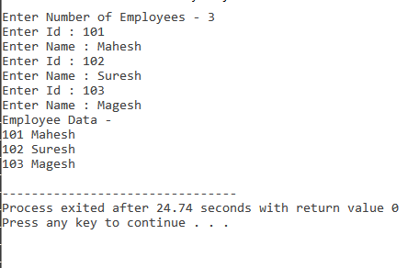

**Explanation:**  
In this example, more than one Employee’s details with an Employee id and name can be stored.

* Employee emp[30] – This is an array of objects having a maximum limit of 30 Employees.
* Two for loops are being used-
  + First one to take the input from user by calling emp[i].getdata() function.
  + Second one to print the data of Employee by calling the function emp[i].putdata() function.

**Example#2:**

**C++**

|  |
| --- |
| // C++ program to implement  // the above approach  #include<iostream>  **using** **namespace** std;  **class** item  {  **char** name[30];  **int** price;  **public**:  **void** getitem();  **void** printitem();  };    // Function to get item details  **void** item::getitem()  {    cout << "Item Name = ";    cin >> name;    cout << "Price = ";    cin >> price;  }    // Function to print item  // details  **void** item ::printitem()  {    cout << "Name : " << name <<            "\n";    cout << "Price : " << price <<            "\n";  }    **const** **int** size = 3;    // Driver code  **int** main()  {    item t[size];  **for**(**int** i = 0; i < size; i++)    {      cout << "Item  : " <<              (i + 1) << "\n";      t[i].getitem();    }    **for**(**int** i = 0; i < size; i++)    {      cout << "Item Details : " <<               (i + 1) << "\n";      t[i].printitem();    }  } |

**Output:**

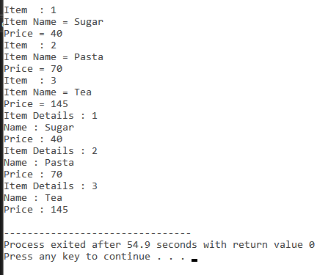

**Advantages of Array of Objects:**

1. The array of objects represent storing multiple objects in a single name.
2. In an array of objects, the data can be accessed randomly by using the index number.
3. Reduce the time and memory by storing the data in a single variable.